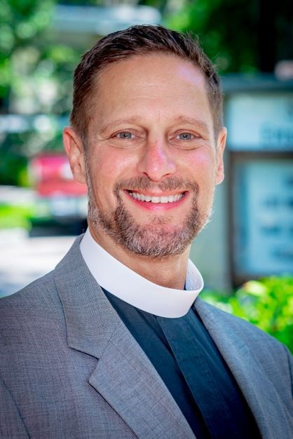St. Catherine of Alexandria Episcopal Church



**THE *WHEEL***

**January 2023**



Epiphany revisited.....

While “commercial Christmas” ends abruptly on December 26, with tree carcasses on the sidewalk and stores already stripped of their Christmas decorations, we in the Christian household know that Christmas is 12 days long! The 12 Days of Christmas are book-ended with the Feast of the Epiphany on January 6. In the early church, and still today in the Eastern churches, the Baptism of the Lord was the event associated with Epiphany, not the coming of the Magi.

Jesus, in his baptism, is affirmed as God’s beloved child, a “big claim” in the ancient world—and in ours, too! He next undergoes a time of discernment and trial in the wilderness and emerges with a calling so strong that even death itself is powerless against his message of God’s love. In his preaching, Jesus encourages us to live “as if” God’s kingdom were already among us… because in many ways, it is!

There are several important points here for us to consider in the Baptism of Jesus. First, Jesus at 30 (the traditional age at his baptism) was not a young man. The average lifespan in Jesus’ time and place was about 45, so Jesus’ new beginning in his ministry happens later in his life. Second, Jesus is affirmed by God not because he’s done anything powerful (yet), but simply because he shows up. All he does is, in a way, his response to the unconditional love of God that he experiences in his baptism.

We at St. Catherine’s can take some lessons from this great feast of the church. First, it’s never too late for a new chapter! Just as Jesus began his ministry as an older person, we are beginning a new chapter together through our Strategic Visioning process. Even though we have a rich and wonderful history, we are called always to look and move forward, never backward. As we gather at the end of this month for our Annual Meeting (Sunday, January 22), we get one more opportunity to embrace God’s future of abundance with courage and wisdom and love.

Like Jesus, we, too, are affirmed as God’s beloved before doing anything. Nothing we do as church is done to “earn” God’s love: God’s love is always there, shining upon us like the Sun. All we need to do is to explore how the Holy Spirit is calling us to respond to that love in gratitude.

This response of gratitude is meant to be the foundation of all our ministries, our stewardship, and our identity… we are God’s beloved, and we are grateful for that, and so we reach out into the world to let everyone else, too, know that they are equally God’s beloved. Our actions as church: actions of service, of welcome, of sharing our resources, are all to be grounded in our gratitude for this powerful experience of acceptance and love. If all our choices and actions were a response of gratitude for this foundational divine love, the Kingdom would indeed be already here!

Epiphany blessings,

Fr. James H. Reho, Rector



# Senior warden report

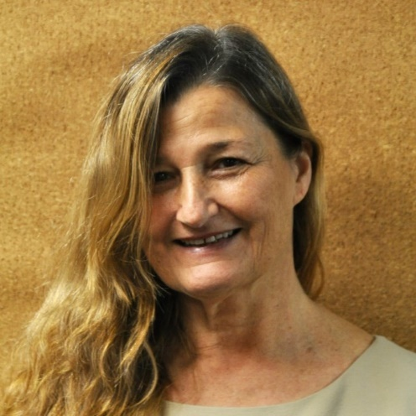I watched this morning a story on the news of a “Christmas Rescue.”  In Buffalo, on Christmas Eve, a developmentally challenged man set out from work to walk home as the incoming blizzard had shut down public transportation.  The temperature plummeted, high winds blew, and mounds and mounds of snow barreled in.  The man became disoriented and tried to cover himself with the tote bag he was carrying.  He stumbled, tried to get up, and attempted to knock on a nearby door. Then, lying there, crying softly, a woman inside heard him, opened the door and found him collapsed on her hearth.  With no hesitation she called for her family to help pick him up to bring him inside.  He was in bad shape; both the bag he was clutching in his hands and his clothes were frozen to him.  Emergency responders were unavailable.  There was no one else.  Through the night they wrapped him in blankets and warmed him with a hair dryer trying to de-ice his clothes, still stuck to his skin.  They were able to reach his sister whose phone number he’d remembered, but no one was going anywhere in that blizzard, and so they did the best they could for the stranger who found them.  On Christmas morning he called out, “Merry Christmas,” and wondered if they might have pancakes!  “Uncle Joey” was rescued shortly thereafter, but remains in ICU with severe third degree frostbite.  Most certainly, however, without the help of an angel named Sha’Kyra, it would have been quite a different story.

**“Arise, shine; for your light has come, and the glory of the LORD has risen upon you….”**  (**Isaiah 60: 1**)

When darkness covers the earth, may we let our light shine, lift our eyes, see, be radiant and reflect the manifestation of Christ to all as did that single mother of three in Buffalo, led by a star on Christmas Eve.

**“Praise the LORD!  Praise the LORD from the heavens; praise him in the heights!….Praise him, sun and moon, praise him, all you shining stars!”** (from **Psalm 148**).

Blessings to you all in the New Year and always,

Manon Alewynse, Senior Warden



# Junior warden report

Notes from the Junior Warden



Our first year under the leadership of our new Rector, Fr James, has come to an end and an even more promising year has begun. We have been guided under our Rector’s leadership to envision our dreams for St Catherine’s.

Six months ago, being elected as Junior Warden was not a position that I remotely thought about, but in many ways it has been the most rewarding of many leadership positions; Vestry Member, Senior Warden, Treasurer, etc.. It gave me a chance to work closely with our Rector, our Senior Warden and many others in the necessary day to day functions that help our church grow into the place where the Holy Spirit is leading us.

There are many challenges that lie ahead of us. I have no doubts that our leadership will enable us to meet them with the ever-present guidance of The Holy Spirit. Thank you for the opportunity to serve. We are truly blessed.

Together in ministry,

Paul Johnson, Junior Warden





 Treasurer’s report

# 

A Note from your Treasurer – January 2023

St. Catherine of Alexandria Episcopal Church In-Gathering of commitments for 2023 Year is slowly coming to a conclusion. As of the writing of this article we have received Sixth Nine (69) commitment letters from parishioners. The goal for our parish is to receive 90-100 commitment letters by end of our Stewardship Campaign. We have Eighteen (18) parishioners who pledged last year but have not yet submitted a commitment letter for 2023. These commitment letters allow our parish leaders to plan for all the missions and activities of our various ministries for the Calendar Year 2023. If you have not yet submitted your Commitment Letter for 2023, we urge you to do so. You can drop your letter in the collection plate at any service, mail or drop off at church office or submit through our website [www.stcathtt.org/donations/pledge](http://www.stcathtt.org/donations/pledge).

Our rector has also previously made the request that each person who made a financial pledge to St. Catherine’s in 2022 consider making a “Thirteenth Month” contribution. If you have not already done so please consider doing so before the end January.

Attached with this article is the St. Catherine’s financial data through November 2022. We can see the detailed data for the month of along with the data “year to date” through November. The information displayed here is a reflection of the parish performance to the operating budget for our parish. Not included here are the “Restricted” fund expenses and revenues. Such items as the recent roof replacement, weekly flowers and other designated expenses are not included in the operating budget.

For the month of November, pledge revenue was ($4,682) under monthly budget with total revenue ($1,472) under budget. In addition, the total expenses were also ($5,189) over budget which gives a total negative performance to budget for November of ($6,661).

Year to date info shows that pledge revenue is still under budget ($26,776) with total revenue ($32,018) under budget. Data also reveals total expenses for the year are also under budget ($9,206). This leaves a net deficit to budget year to date of ($22,812).

It is also worth noting that for the month of November our Endowment Investment generated a positive gain for the second consecutive month. This is a good sign for our parish.

Our parishioners to date have been very faithful in remaining committed to their pledge dollars for the year. It is important for our parishioners to fulfill their commitment for 2022 and make a commitment for the year 2023 if you have not done so already.

*(continued on next page)*



Thank you for your commitment to our parish and to the ministries through which we serve our community.

Terry Bechtel – Treasurer



# Musical notes

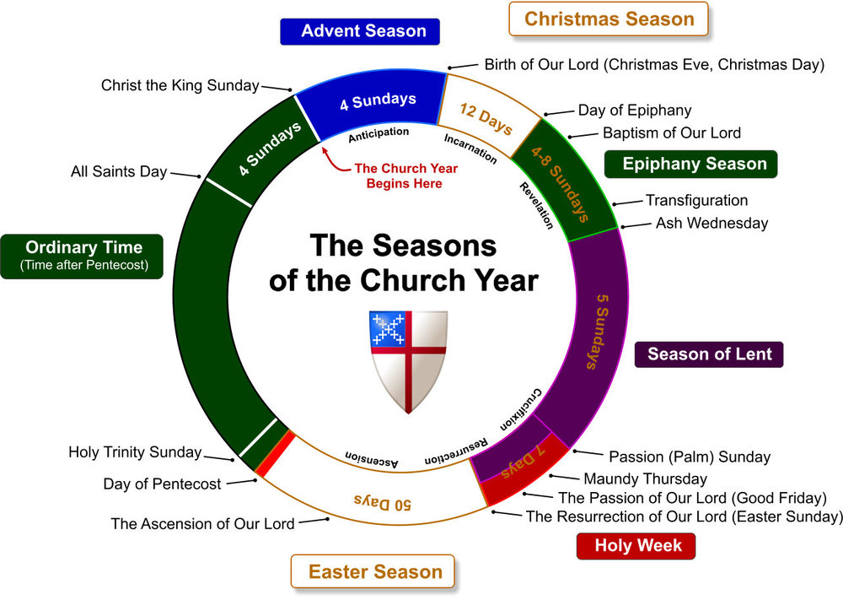

Over the course of a year, the Episcopal Church retells in appointed scripture and song, the love story between God and God’s people. The themes of the church year are marked by changes in music, worship and in the colors with which we ‘dress’ the church.

* ***Advent*** reminds us of the promise of salvation through Jesus. We are filled with joyful anticipation.
* ***Christmastide*** begins with the birth of Jesus and continues to January 6, Epiphany, when we celebrate the coming of the Magi and the prophetic gifts of gold (kingship), frankincense (divinity), and myrrh (suffering and death).
* ***The Epiphany*** “season” is a recounting the many ways in which Jesus was made known through miracles and signs.
* ***Lent*** is a time for prayer, fasting and almsgiving (works of charity). We are called to repentance in preparation for the celebration the mystery of Christ’s triumph over death at Easter. Lent ends on Maundy Thursday.
* ***Holy Week*** is the culmination of Lent. The three services (Maundy Thursday, Good Friday, and the Great Vigil of Easter) are continuations of one another. Beginning with the institution of the Eucharist and the new commandment to love and serve one another (*mandatum*) we move to the somber reading of the Passion of our Lord on Good Friday and finally to the retelling of our collective salvation history at the Great Vigil of Easter.
* ***Eastertide***, also known as the Great Fifty days, presents us with the themes and history of the early Church. In Eastertide, the first reading which is usually from the Old Testament is replaced by readings from the Acts of the Apostles. This season ends on Pentecost, the day on which we celebrate the Holy Spirit.
* ***The Season after Pentecost*** *(“*Ordinary time”) continues until the Christ the King, the last Sunday of the church year. After Christ the King Sunday, we begin the year again.

Linda Ruescher, Music Director and Organist



Strategic visioning

### January Strategic Visioning Update

**Epiphany, a Time of Joy: The Annual Meeting and Strategic Visioning**

Our Annual Meeting will take place on Sunday, January 22, after a single 9:00 AM liturgy. Just as we have reinvigorated many of our ministries during 2022 we will also recharge our Annual Meeting experience! This gathering is meant to be a *celebration* of who we are as St. Catherine’s, of how God is calling us to be God’s Church in this place and time.

By the time of our Annual Meeting, much (and maybe all) of the data from our St. Catherine’s workbooks will be compiled, and at the Annual Meeting I will offer a glimpse into these results through a short presentation. This is an important step toward the building of our multi-year plan. This multi-year plan will ensure that our choices of how to use our shared sacred resources of money, time, and our talents will be driven by our collective vision and not by any particular group or individual.

In addition to this Strategic Visioning presentation, we are planning a few surprises for the Annual Meeting to help make this occasion the festive celebration that it is meant to be. Please plan to attend the 9:00 AM liturgy on Sunday, January 22 and please plan to stay afterward for our Annual Meeting!

Together in ministry,

Fr. James +



##### Our 2023 Pledgers… so far!

Our deep gratitude to the **70 pledging families and individuals** who have returned their Certificates of Promise with their 2023 commitments of time, talent, and treasure!

We know some of you are still finalizing your Certificate of Promise and we look forward to adding you to the number of those who have pledged their time, talent, and treasure for 2023. Remember, the Certificate of Promise is for 2023 and can be fulfilled in many ways and on various timelines. *Now is the time we need your commitment, as we are finalizing our budget for 2023.*

If you have not made a pledge, and wonder about this spiritual practice, please ask a member of the Vestry or anyone on this list about pledging. If you need a *Certificate of Promise*, you can find them in the church Narthex or can get one by calling the office (813-988-6483). Join the **12** (so far!) **new pledging families and individuals** in supporting our Mission and Vision for 2023.

Blessings,

***Your St. Catherine’s 2023 Stewardship Team***



Cursillo is a three-day weekend, held at DaySpring Conference Center in Ellenton. It begins on a

Thursday evening and ends on Sunday. During the three days, participants hear a variety of talks given by lay persons and clergy.

A Cursillo weekend is not a retreat... (it is where shared) prayer, worship study, music, fellowship, laughter, and tears all work together to create a loving atmosphere where one can feel the reality of God’s free and unconditional love. The Holy Eucharistic is celebrated daily.

St. Catherine’s has many in the parish who have attended this extraordinary weekend which has left a life-long way to individual spirituality. We are available to speak with you and answer any questions you might have. Also, you will find a link on the home page of the Diocese for more information.

[www.episcopalswfl.org](http://www.episcopalswfl.org/)

DeeDee Schatzberg Cursillo liaison



# Adult faith formation

## Anglicanism 101 with Fr. James Reho aka… “Confirmation Class”

**Sundays 9:00 AM – 9:45**

**Final classes: January 8, 15, 29**

Are you fairly new to the Episcopal/Anglican tradition? Or are you a life-long Episcopalian who might still have some questions about the teachings, practices, and history of our church? Whoever you are, and however deeply you may have investigated the Episcopal Church and Anglican history, this course has something for you!

Join Fr. James each Sunday in the Parish Hall from 9:00 AM – 9:45 AM as we explore various aspects of the Episcopal Church. Topics include:

* Church History: how did we get here?
* How does the Episcopal Church interpret the Bible?
* How is the church is governed?
* How did Anglicanism begin?
* What are the beliefs of the Episcopal Church?
* Are we Episcopalians *Catholic* or *Protestant*?
* What are Anglicans like around the world, and how are we related to them?
* Who is the Archbishop of Canterbury, and why do we pray for him each week?

In Anglicanism 101, we will explore these and other questions through presentations, discussions, and videos. Join Fr. James for an accessible yet informative time and learn more about who we are!

This class serves as preparation for **CONFIRMATION** and **RECEPTION** into the Episcopal Church; please see Fr. James if you or someone you know is interested in these rites. That being said… all are welcome! Latecomers and newcomers always welcome!



children’s chapel

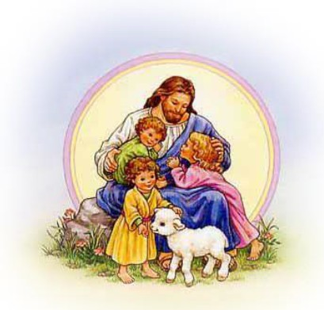**Welcome to**

##### Children’s Chapel

Children’s Chapel at St. Catherine’s is designed to provide a child-friendly, authentic worship experience for children from 18 months to about 8 or 9 years of age. (Older children are welcome, and can help with the service.) Children who may find it challenging to participate in the main church service typically enjoy and relate

well to our Children’s Chapel service.

In planning our worship service, we have followed the **Liturgy of the Word** of *The Holy Eucharist, Rite 2*, from

***The Book of Common Prayer***. We use music, prayers, and readings written specifically for children. Our service ends at the time of *The Peace* in the main service. Children younger than 5 are returned to the nursery or brought to parents in church, at the parents’ discretion. Those children who are 5 and older are welcomed to the main service

in the Sanctuary.

Our Children’s Chapel service begins at 10 AM, just as the main worship does. Children’s Chapel takes place in

the St. George’s Room in the classroom wing. Children have the best experience if they can be in Chapel on time, so that they can experience the continuity of the worship experience. We will be including **Preparation for Communion** lessons for the older children (ages 4 and up), at the beginning of ser vice, about once a month. When such a lesson occurs, your child will receive a coloring page, and you will receive a letter of explanation.

This allows you to discuss the information with your child, and help him/her to better understand what we talked about.

The worship service includes 5 songs. Two of them are the same every week. The first is a welcome song, **Hello, Everybody**, and the other is **We Believe**, a song based on the Apostle’s Creed. The other three songs are usually sung for a month at a time, and are intended to match the season of the year or the readings. It is my experience that children learn songs better through repetition, and the songs become imbedded in their memories, for years to come. If there is time after the service, we sing a few additional songs. We can provide you with the words and

music for some of our songs if you are interested, so you can sing them with your children.

Our service includes the Call to Worship, an Opening Collect (Prayer), Psalm 23, a Reading (usually, a New

Testament Bible story), Discussion of the Story, Prayers of the People, Confession, and the Lord’s Prayer. All of

these have been written for children, so that they can understand and relate to the words. We can provide the Order of Worship for you, if you are interested. We welcome your partnership in encouraging your child to understand and learn these prayers.

Please feel free to worship with us in Children’s Chapel at any time! We would love to see you and invite you to share this worship experience with your child.

Thank you,

Norris Johnson, Children’s Chapel Coordinator



around sT. caTherine’s



**PLEASE MAKE SURE YOUR GIFT IS WRAPPED!**



around sT. caTherine’s

#### FIRST SUNDAY OF THE MONTH

Any loose offering made on the first Sunday of the month goes to the Rector’s Discretionary Fund.

##### ST. VINCENT de PAUL FOOD PANTRY

St. Catherine's supports the Corpus Christi Society of St. Vincent de Paul Food Pantry. Food donations help those in Temple Terrace and surrounding communities with food insecurities. Place donations of non-perishable food items in the shopping baskets in the church entrance.

###### SUGGESTED DONATIONS

Peanut Butter Powdered Milk Canned Vegetables Canned Pasta Sauce Beans - canned or dry Canned Fruit Canned Soup Canned Meat / Tuna Cereal

The food pantry also needs **clean empty egg cartons** and **plastic grocery bags**.

#### WISDOM PRACTICE CIRCLE IS BACK!

“Wisdom is not knowing more. It is knowing deeper, knowing with more of you.” Cynthia Bourgeault, Episcopal Priest and Theologian.

**Saturday, January 21, 3-5PM** in person in the St. George Room (Children’s Chapel) or by Zoom (contact Carol below for Zoom credentials)

Come join us then! For more information contact

Carol Harlow 813-391-1884 or [**walker_52_@msn.com**.](mailto:walker_52_@msn.com)

#### ADULT CHRISTIAN EDUCATION

Join us on Facebook for a weeklong discussion/blog

[Adult Christian Education @ St. Catherine](mailto:AdultChristianEducation@St.Catherine)’s and click on “Join Group”



around sT. caTherine’s

#### ALTAR FLOWERS AND SANCTUARY CANDLE

**Sponsoring the flowers and/or sanctuary candle** allows us to remember loved ones or celebrate families and friends. Click here: https://signup.com/go/RZCDMmo, to sign up for an upcoming date. When signing up for flowers, please allow two weeks to place the order with the florist.

#### ST. CATHERINE’S LIVESTREAM

**The 10 AM Sunday service is livestreamed** to **Facebook**.

#### NAME TAGS

Wearing name tags during worship services and other parish events at St. Catherine’s has proven to be an important practice for several decades in welcoming newcomers and visitors, as well as getting to know each other a little bit better. We believe it is time to revive and restore the wearing of name tags, and to make this happen, we would greatly appreciate it if you would do the following:

* Check the name tag rack in the narthex, and determine if you have a name tag. Please wear your name tag when inside the church.
* No name tag, add your first and last name to the form found on the table in the narthex just outside the Sanctuary. A new name tag will be placed on the appropriate peg on the rack.

around sT. caTherine’s



Service Rota Calendar

Service Rota Calendar



##### ALTAR FLOWERS and SANCTUARY CANDLE

Sponsoring the flowers or candle is a beautiful and powerful way to remember our loved ones and to celebrate our families and friends. Sign up for Altar Flowers or the Sanctuary Candle by contacting the church office or clicking on the following link: [www.SignUp.Org.When](http://www.SignUp.Org.When/) signing up for flowers, **please allow two weeks to allow time to place the order with the florist.**

Suggested Donation $50 Suggested Donation $10

January 8, 2023 **Bartlett Memorial**

**Bert & Sybil Catala**

January 15, 2023 **Eleanor Wells**

January 22, 2023 **Robert Tucker**

January 29, 2023 ***still available***

February 5, 2023 ***still available***

February 12, 2023 ***still available***

February 19, 2023 ***still available***

February 26, 2023 ***still available***

and January 8, 2023 **Sandy Boehning**

January 15, 2023 **Suzette Lemrow**

January 22, 2023 **Robert Tucker**

January 29, 2023 ***still available***

February 5, 2023**Sandy Boehning**

February 12, 2023 ***still available***

February 19, 2023 ***still available***

February 26, 2023 ***still available***

**BIRTHDAYS and ANNIVERSARIES**

|  |  |  |  |
| --- | --- | --- | --- |
| Alex Szczesny | 01/01 | Amanda Walker | 01/18 |
| Anna Allen | 01/03 | Mary Ann Tucker | 01/21 |
| Viki Jackson | 01/04 | Rick Schultz | 01/21 |
| Louise Channell | 01/06 | James McIlwain | 01/21 |
| Gloria Edwards | 01/06 | Donald Whittemore | 01/25 |
| William Reid | 01/08 | William Walker | 01/28 |
| Leo Branch | 01/13 | Marlene Williams | 01/28 |
| Kevin Carpenter | 01/13 | Evelyn Dixon | 01/30 |
| Bridgette Kolka | 01/17 | John Grupposo | 01/30 |
|  |  |  |  |
|  |  |  |  |



|  |  |
| --- | --- |
| Paul & Norris Johnson | 01/09 |
|  |  |
|  |  |

**St. Catherine of Alexandria Episcopal Church**

502 Druid Hills Road Temple Terrace, FL 33617

Worship Services

Sunday Holy Eucharist Rite I :00 AM Sunday Choral Eucharist Rite II at 10:00 AM

Wednesday Holy Eucharist and Service of Healing 12:10 PM

Office Hours

Monday through Thursday: 8:00 AM - 12:00 PM

Staff

The Rev. Dr. James Reho, Rector [FrJames@stcathtt.org](mailto:FrJames@stcathtt.org)

Lori Reho, Acting Parish Administrator [admin@stcathtt.org](mailto:admin@stcathtt.org)

Linda Ruescher, Director of Music & Organist [linda.ruescher@gmail.com](mailto:linda.ruescher@gmail.com) Rachel Rubottom, Christian Education Coordinator [rachel@stcathtt.org](mailto:rachel@stcathtt.org) Brenda Menendez, Financial Administrator [brenda@stcathtt.org](mailto:brenda@stcathtt.org)

**Pastoral Emergencies / Hospital Visits**

Please let us know if you or other parishioners are in the hospital.

For pastoral emergencies, call the Rector, Fr. James Reho, 917-526-0746 (cell).

##### Church Email List

We communicate events and things of interest via email to our parishioners. If you would like to be on this list, please fill out the Welcome card found in the pew and give it to an usher or contact the church office. We do not share this information with anyone.

##### Find us on Facebook

facebook.com/StCatherinesEpiscopalChurchTempleTerrace/

If you are on our Facebook page, click “like” and pass the word! Post pictures and comment and the page will have a wider audience. We have a policy of not putting children / youth names with pictures on the internet; please do not tag anyone under 18.

##### The Rewarding Formula



Go to [www.stcathtt.org](http://www.stcathtt.org/) and click Resources in the blue bar at the top of the page then click on the Amazon.com button **=** commissions for St. Catherine's at no extra cost to you!

20